PATIENT NAME:
INSURANCE ID#: DOB:
ADDRESS:
PHONE #:
MEDICARE DESCRIPTION AND PROCEDURE CODES:
- POWER WHEELCHAIR GROUP STANDARD CAPTAIN CHAIR - K0816 ;
- BATTERY - E2365

Power Wheelchair Pride Jazzy Elite ES

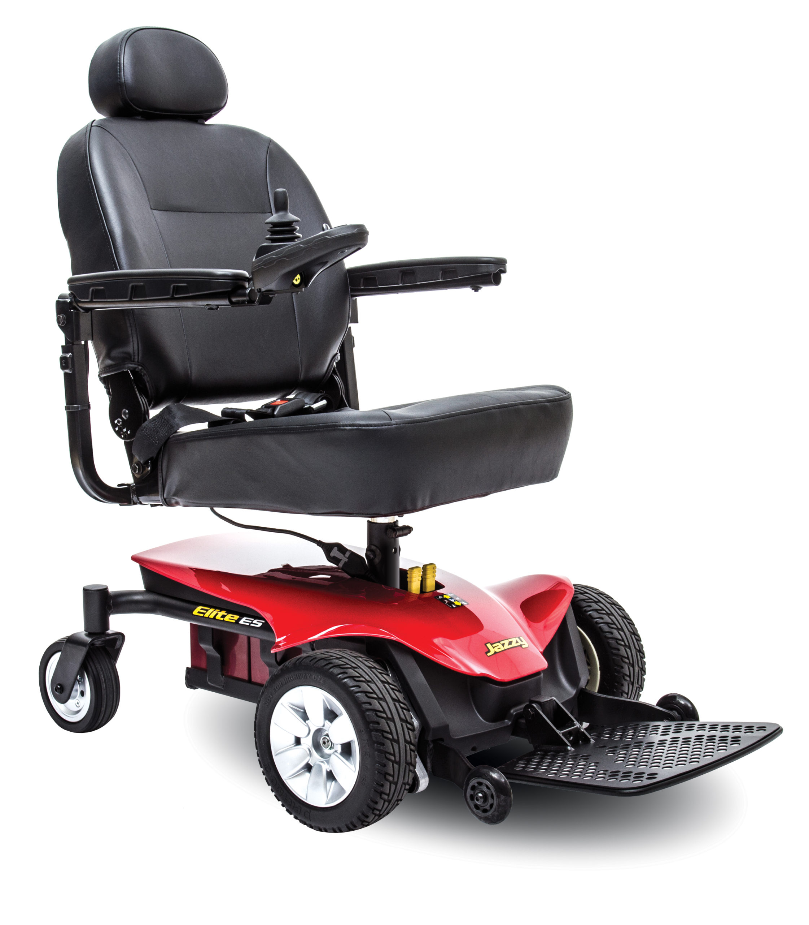

Description:
An experience so superior, it can only be elite. The Jazzy® Elite ES1 features large, front-drive wheels to absorb the bumps and uneven surfaces of everyday life. The comfortable, high-back seat gives you the support you need all day, every day.
• Depth-adjustable, limited-recline, fold-flat, high-back seat
• Universal, fixed, in-line joystick mount
• Flip-up foot platform
• Black, flat-free, non-marking tires
• Easy-access free-wheel lever
• 60” lap belt

CATEGORY | SPECIFICATION
Model | Jazzy® Elite ES
Weight Capacity | 300 lbs.
Turning Radius1 | 24.75"
Width1 | 22.75"
Length1,2 | 34.75"/41" (with footplate)
Maximum Speed3 | Up to 4.0 mph
Ground Clearance1 | 1.85" at motors
Front Wheels | 3" solid anti-tips
Drive Wheels | 9" solid
Rear Wheels | 6" solid casters
Drivetrain | Two motor, in-line, front-wheel drive
Braking System | Regenerative and electro-mechanical
Suspension Type | Limited
High-Back Seat (max. size) | 20"W x 20"D
High-Back Seat-to-Floor Range | 21.5” – 23.5”
Standard Electronics | 40A, PG GC3
Battery Size (2 required) | 12 volt, U-1
Standard Battery Charger | 3.5A, off-board
Per-Charge Range3,6 | Up to 15 miles
Battery Weight5 | 25 lbs. each
HCPCS | Group 2: Standard (K0822/K0823)
Weight of Heaviest Piece4 | 69 lbs.
Standard Seat Weight | 50.2 lbs. (comfort, high-back)
Standard Seat Size | 16" x 16"-18"  18" x 18"-20"  20" x 18"-20"
Warranty | 5-year limited on frame;  13-month limited on electronics;  13-month on drive motors;  13-month limited on batteries.

**Patient Agreement:** I, ___________________________________ (Patient Name), acknowledge that I have reviewed the power wheelchair depicted in the accompanying picture. I understand its features and specifications and agree that this wheelchair meets my mobility needs as assessed by my healthcare provider. I consent to accept and use this specific power wheelchair as part of my mobility solution.

Patient’s Signature:___________________________________________________________ Date:_____________
Signature if other than patient:___________________________________Relationship:_____________________
Name if other than patient:_______________________________________________________________________
Reason patient is unable to sign:__________________________________________________________________
Evaluator’s Signature:_____________________________________________________ Date:________________
Evaluator’s Name (printed):______________________________________________________________________

